Lab 7

Isaiah Hoffer

PART A:

LAB Q A7 TEST1:

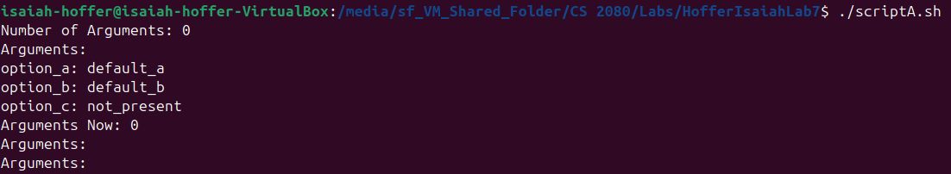

LAB Q A7 TEST2:

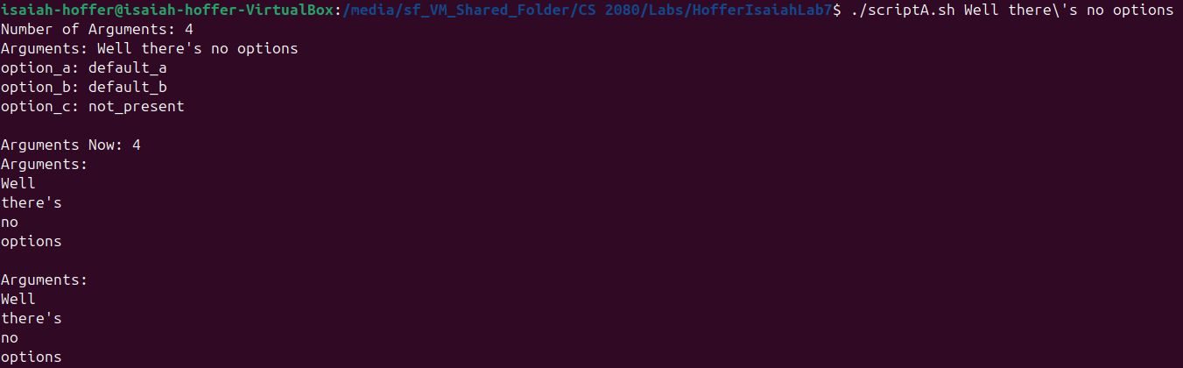

LAB Q A7 TEST3:

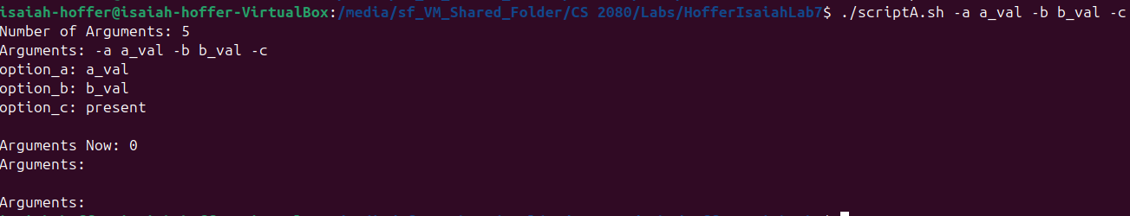

LAB Q A7 TEST4:

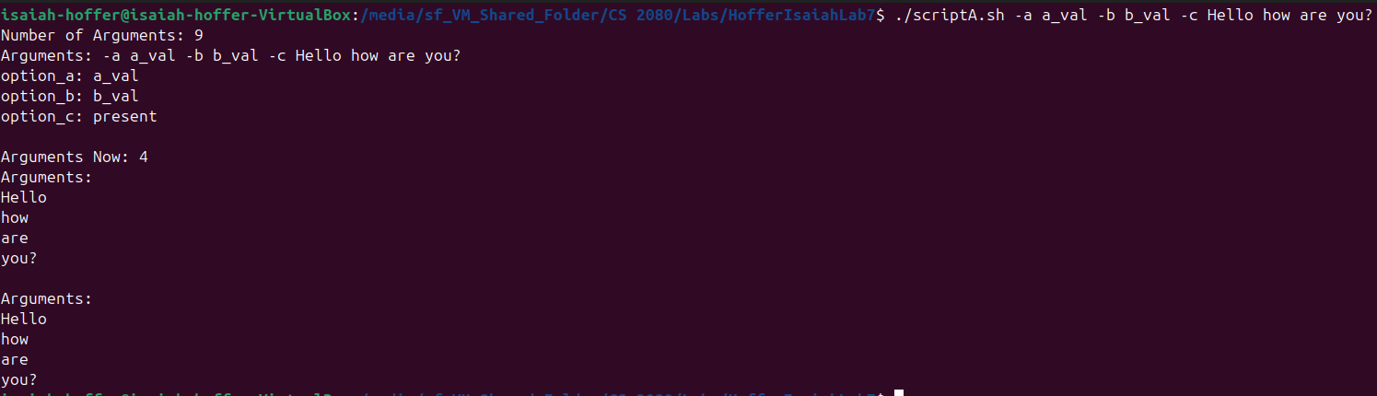

LAB Q A7 TEST5:

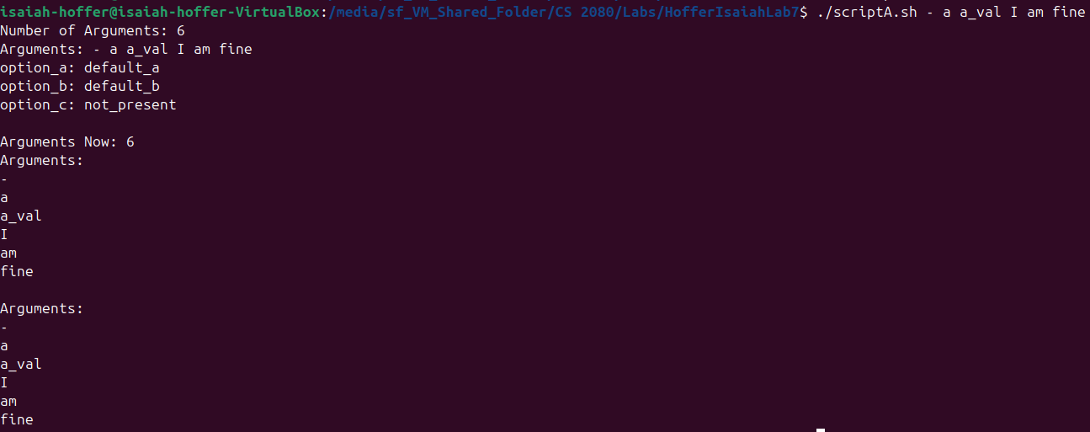

LAB Q A7 TEST6:

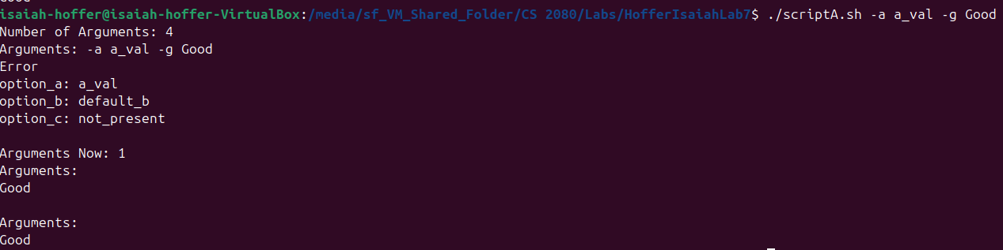

LAB Q A SCRIPT:

#! /bin/bash

# ScriptA.sh

#Section A1

# Default Option Parameters

option_a="default_a"

option_b="default_b"

option_c="not_present"

echo "Number of Arguments: $#"

#Displaying Arugments

echo "Arguments: $@"

#Section A2

#Stop Error Message

optstring=":a:b:c"

#Giving Values to Option Variables

while getopts $optstring optname

do

case $optname in

a) # Set option_a to $OPTARG

option_a="$OPTARG"

;;

b) # Set option_b to $OPTARG

option_b="$OPTARG"

;;

c) # Set option_c to present if it is found

option_c="present"

;;

\?) # Print Error if \? error is found

echo "Error"

;;

esac

done

#Printing Options

echo "option_a: $option_a"

echo "option_b: $option_b"

echo "option_c: $option_c"

echo ""

#Section A4

#Shifting 1

shift $((OPTIND - 1))

#Remaining Arguments

echo "Arguments Now: $#"

#Section A5

#Print Arguments Again

echo "Arguments: "

for i in $@

do

echo $i

done

echo ""

#Section A6

#Print And Removing Remaining Arguments

echo "Arguments: "

while (( $# != 0 ))

do

echo $1

shift

done

exit

PART B:

LAB Q B TEST1:



LAB Q B TEST2:

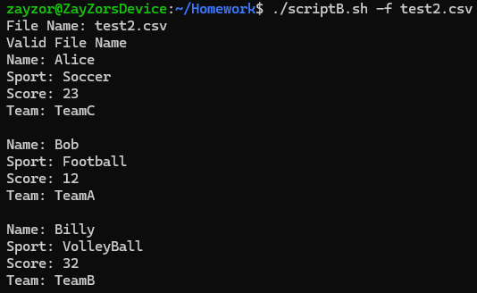

For some reason I could get permission in the virtual machine, so I had to copy everything over to my ubuntu I have on my main machine that why it looks different

LAB Q B TEST3:



LAB Q B TEST4:



LAB Q B TEST5:

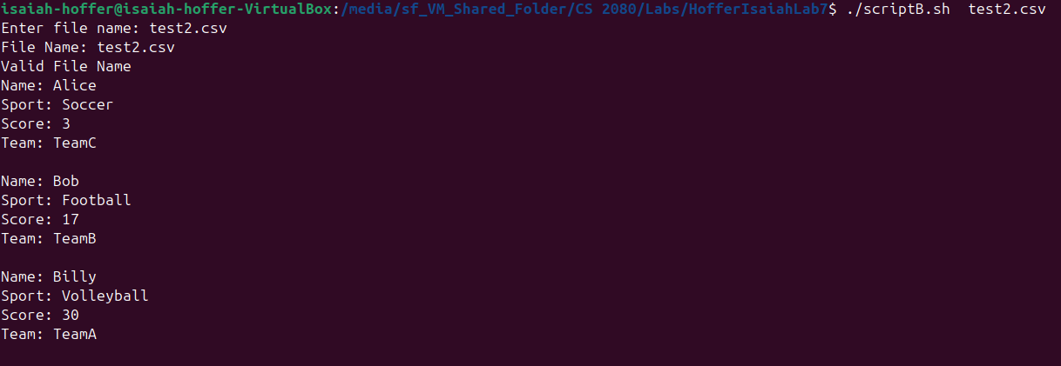

LAB Q B SCRIPT:

#! /bin/bash

# ScriptB.sh

# Section B1

filename_var=""

#Using getopts to read -f option

while getopts ":f:" opt

do

case "$opt" in

f)

filename_var=$OPTARG

;;

\?)

echo "Error"

;;

esac

done

#If -f was not found, prompt user for name

if [ -z $filename_var ]

then

read -p "Enter file name: " filename_var

fi

#Printing File Name

echo "File Name: $filename_var"

#Section B2

#Checking if file is regular, exists, and has content

if [ -f $filename_var ] && [ -s $filename_var ]

then

echo "Valid File Name"

IFS=,

#Read each line of field by field

while read name sport score team

do

echo "Name: $name"

echo "Sport: $sport"

echo "Score: $score"

echo "Team: $team"

echo ""

done < $filename_var

else

echo "Error: $filename_var not a valid file"

exit 1

fi

#Section B3

exit $?